1. **List of Strings**
   1. Create a list containing strings, each string represents a color: **Blue, Red, Black, Pink, Brown, Yellow**… (you can also add your favorite colors too), and print out the list

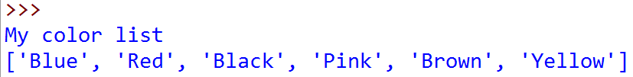

* 1. Print out the color at index 3 in this list, expected output:



* 1. Print out the color at index “**i**” in this list, “**i**” is entered by user, expected screen output:

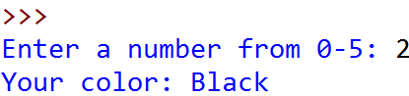

* 1. Print out **all** of the colors in the color list, in **two ways**, expected screen output:



***And***

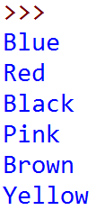

* 1. Write a program that asks user for their favorite color. Look for this color in the given list. If the color is found, print out **the index** of this color in the list. If not, print out “**Sorry, I could not find your color**”. Expected screen output:

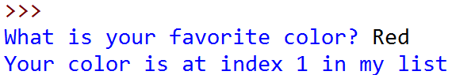

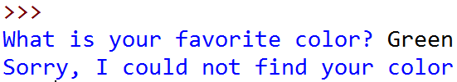

1. **List of Numbers**

You are a shepherd who owns a flock of sheep



**You**

Each of your sheep of your flock has different size:



* 1. Create a list to represent the sizes of your flock, using list**,** and print all of your flock size, expected screen output:

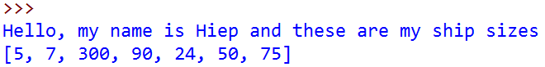

* 1. At the end of each month, you have to choose **one and only one** sheep to shear and thus you want to choose the **biggest one** to maximize your profit. Write a program to search for the **biggest** sheep in your list:

*Hint: Google “Python List max function”*

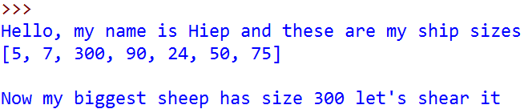

* 1. When your biggest sheer, its size will return to the default size, which is 8. Print out your ship size after shearing the biggest one:

*Hint: Google “Python List index function”*

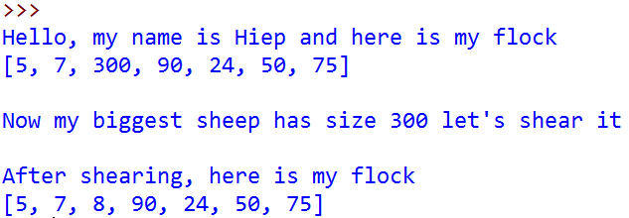

* 1. In the following month, EVERY sheep in your flock grow, they have their size increased by 50. Print them out

*Hint: Ask Coach if you need help* ☺

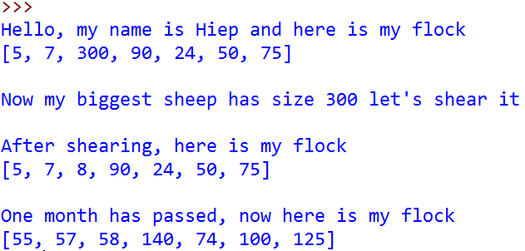

* 1. Let do this process for 4 months (or as long as you want):

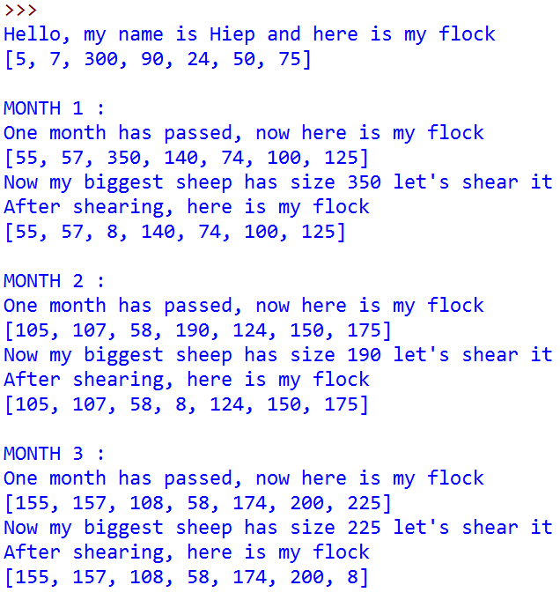

* 1. After day by day shearing shapes, you became bored. You want to sell your flock to travel the world. In order to have fair trade, you must now calculate the total size of your sheep and then the expected money you can get from your flock before going to the market.

Write a program to calculate the total size of your sheep as well as the money you would have. Expected screen output:

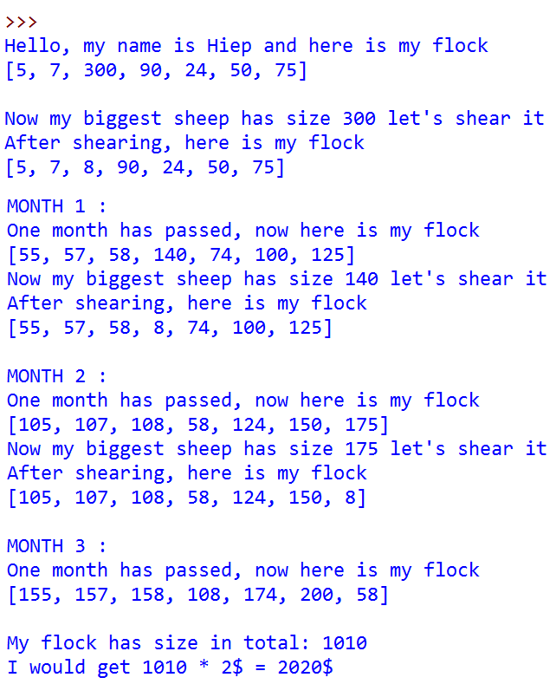

1. **Range**

There are at least two ways to print all numbers of a range

The **first way** is to use for loop:

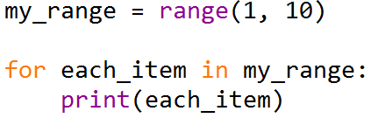

The **second way** is to convert the range to list using list’s extend function and then just display it:

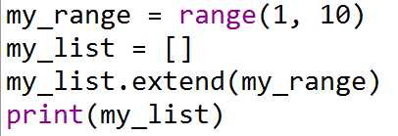

**#TODO**

Using range(), **create** and **print out** the following sequence:

|  |  |
| --- | --- |
| **Name** | **Sequence** |
| range1 | 0, 1, 2, 3, 4, 5, 6 |
| range2 | 1, 4, 7, 10 |
| range3 | 5, 4, 3, 2, 1 |
| range4 | 6, 4, 2, 0, -2 |

1. **Range of numbers**
   1. Calculate the sum of sequence listed in
   2. Calculate the following expression
 $$S=1+\frac{1}{2}+\frac{1}{3}+…+\frac{1}{10}$$

  3. Calculate the sum of the following expression, with ‘n ‘entered by users
 $$S=1+\frac{1}{2}+\frac{1}{3}+…+\frac{1}{n}$$

  4. Calculate the sum of the following expression, with ‘n’ entered by users

$$S=1+\frac{1}{2!}+\frac{1}{3!}+…+\frac{1}{n!}$$